User Guide

1.Check the PoE switch
(1) Please check the enclosure, RJ45 ports, LED indicators, sure they are ok.
(2) Connect the PoE switch with power, make sure the initialization of PoE switch is available as below:
POE indicator is off at the beginning when power connected
PWR indicator is on and keeps
Other green indicators will be on, then off after one or two seconds

2.Connection cables
(1) Connected the PoE switch to PD( like IP camera, wireless AP) by CAT5 or 6 cables
(2) Connected the external power adapter to PoE switch
(3) Connected the power cord to AC plug

Caution
1. In order to safety, please non-professionals don’t open the casing of product;
2. Please be careful the risk of strong current and security protection when products carry power;
3. Please select the right power adaptor provide power for PoE switch, before using please confirm if is it accord with the requirement of PoE switch;
4. Please don’t use PoE switch under the humid environment, avoiding water go into the product inside caused PoE switch breakdown.
5. Please start the power after the circuit connected;
6. Please don’t plug-in and plug-out the connection cable when product is carrying on power;
7. Please don’t use PoE switch under somewhere with more dust and EME;
8. Please don’t put heavy thing on PoE switch, in order to having an accident;
9. According to the IEEE802.3AF/AT standard, Please use the Cat.5 or above, transmission distance 250 m;
10. Please don’t exceed the maximum output power of PoE switch when it connects more than one PD device;
11. Suggestion that PoE switch use for indoor, if you want to use for outdoor, Please install waterproof box

4+2 10/100Mbps PoE Switch
AI104

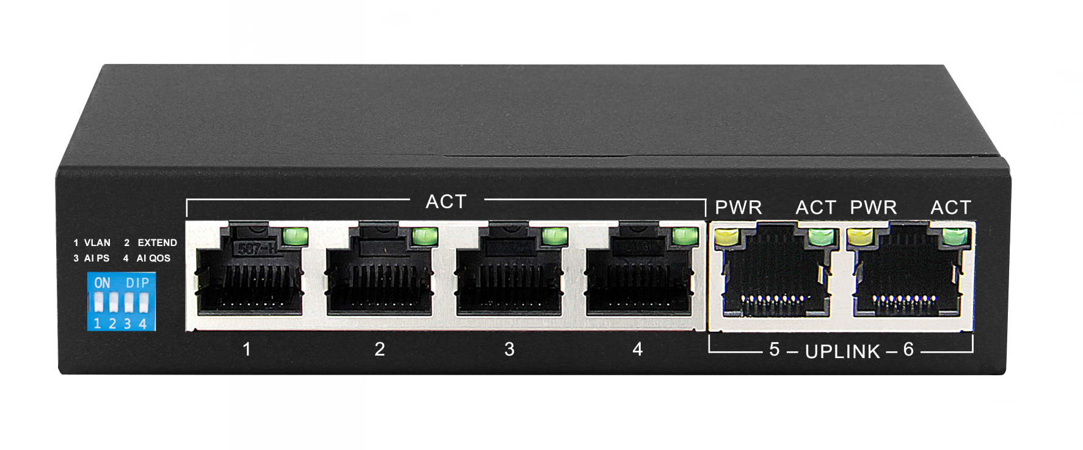

Overview
AI104 is 6 port intelligent PoE switch with 4 working modes, AI VLAN mode, AI Extend mode, AI PoE mode, AI QoS mode. By default, all ports are free to communicate; when AI VLAN mode is enabled, 1-4 ports are isolated from each other, which can effectively suppress network storms and improve network performance. In the AI Extend mode 1-4 ports can effectively transmit distances up to 250 meters, which is suitable for remote monitoring and power supply. In the AI PoE mode, the switch automatically detects the working status of the PD device and finds that the abnormal device automatically restarts the device. In the AI QoS mode, when the device is congested, the video data is processed preferentially to make the video smooth. The device supports the standard IEEE802.3 af/at protocol, which can automatically detect and identify the PDs that comply with the IEEE 802.3af/at standard and provide power for them, so there is no need to worry about PoE or non-PoE devices that can damage private standards.

Key Features
- AI Extend: 1-4 ports support 250 meters long distance power supply (should be use cat5e or cat6 cable)
- AI VLAN: Isolating ports 1-4 to each other can effectively suppress network storms and improve network performance.
- AI QoS: Customize application priority to improve network sensitivity. For example, video priority, monitoring transmission is more smooth
- AI PoE: Automatically detect the power receiving port, find the dead device, power off and restart the device
- Support wireless access points (APs) and network surveillance cameras via Cat 5 cables;
- Support IEEE802.3af/at standard PD device;
- Supports uplink port auto-flip (Auto MDI/MDIX)
- Adopt store-and-forward exchange mechanism
- Intelligent power supply, lowest power consumption, ensure the power demand of the PD terminal
- With power circuit protection, it can protect the security of the back-end equipment;
- Zero configuration feature power is automatically supplied to the adaptive device;
- No fan design to achieve energy saving and environmental protection;
- Support port no link power saving function;

Technical Specification
Network Port | · 4 10/100Mbps PoE RJ45 port ( Port 1~ port4)
Network Port | · 2 10/100Mbps RJ45 port uplink(Port5~port 6)
Transfer Rate | · 100Mbps full Duplex, 10 or 100Mbps Half Duplex
Network protocol and standard | · IEEE 802.3i, IEEE 802.3u, IEEE 802.3x, IEEE 802.3af, IEEE 802.3at
Performance | ·Bandwidth: 1.2Gbps (no block))
Performance | · Network delay(100 to 100M bps): maximum 20 μs (using 64 byte packet)
Performance | ·Frame filtering and transmission rate:
Performance | 10M port maximum 14,800pps
Performance | 100M port maximum 148,800pps
LED indicator | · Power
LED indicator | · LINK/ACT
POE pin | 1/2(+), 3/6(-);
Power | ·Max power for single port 36W
Power | ·External power adapter: 60W;
Dimensions | ·Size(LxWxH): 125 x 75 x 27mm
Dimensions | ·Weight: 0.5kg
Environment | ·Operating Temperature: 0°~40°C
Environment | ·Operating Humidity: 10%~ 90%, Non-condensing
EMC | · CE Class B
EMC | · FCC Part 15, Class B
EMC | · VCCI Class B
EMC | · C-Tick
Safety regulation | · CE/ROHS/FCC/CCC

