User Guide

1.Check the PoE switch
(1) Please check the enclosure, RJ45 ports, LED indicators, sure they are ok.
(2) Connect the PoE switch with power, make sure the initialization of PoE switch is available as below:
POE indicator is off at the beginning when power connected
PWR indicator is on and keeps
Other green indicators will be on, then off after one or two seconds

2.Connection cables
(1) Connected the PoE switch to PD( like IP camera, wireless AP) by CAT5 or 6 cables
(2) Connected the external power adapter to PoE switch
(3) Connected the power cord to AC plug

Caution
1. In order to safety, please non-professionals don’t open the casing of product;
2. Please be careful the risk of strong current and security protection when products carry power;
3. Please select the right power adaptor provide power for PoE switch, before using please confirm if is it accord with the requirement of PoE switch;
4. Please don’t use PoE switch under the humid environment, avoiding water go into the product inside caused PoE switch breakdown.
5. Please start the power after the circuit connected;
6. Please don’t plug-in and plug-out the connection cable when product is carrying on power;
7. Please don’t use PoE switch under somewhere with more dust and EME;
8. Please don’t put heavy thing on PoE switch, in order to having an accident.;
9. According to the IEEE802.3AF/AT standard, Please use the Cat.5 or above, transmission distance 250 m;
10. Please don’t exceed the maximum output power of PoE switch when it connect more than one PD device;
11. Suggestion that PoE switch use for indoor, if you want to use for outdoor, Please install waterproof box

8+2 10/100Mbps PoE Switch
AI108

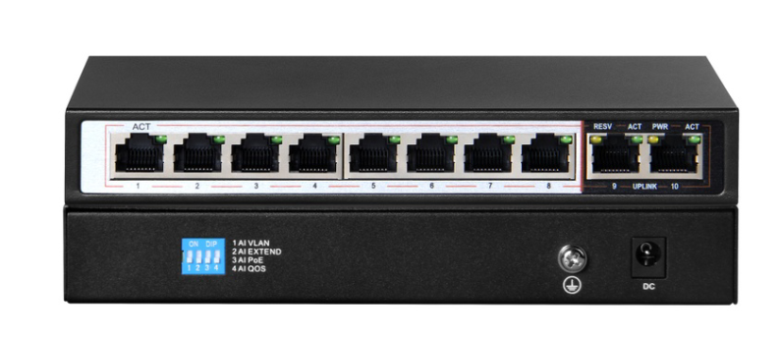

Overview
AI108 is a 10-port smart POE switch. It has 4 working modes, AI VLAN mode, AI EXTEND mode, AI PoE mode, AI QOS mode. All ports are free to communicate by default; In AI VLAN mode, 1 -8 ports are isolated from each other, which can effectively restrain network storms and improve network performance. In AI Extend mode, the effective transmission distance of 1-8 ports can reach 250 meters, which is suitable for remote monitoring and power supply. In the AI PoE mode, the switch automatically detects the working status of the PD device and finds that the device abnormal automatically restarts the device. In AI QOS mode: the video data will be processed preferentially when the device is congested to make the video smoother
The device supports IEEE802.3af/at standard, which can automatically detect and identify the PDs that comply with the IEEE 802.3af/at standard and provide power for them, so there is no need to worry about PoE or non-PoE devices that can damage private standards.

Key Features
- AI Extend: 1-8 port supports 250M meters long distance power supply (recommended cat 5 or above)
- AI VLAN: Isolating ports 1-8 from each other, restrain network storms effectively and improve network performance
- AI QOS: Customize application prioritization and increase network sensitivity. For example, video priority, monitoring transmission more smoothly
- AI POE: Automatic detection power of port, power off and restart the device if find dead machine
- Supports IEEE 802.3af/at standard, automatically detects and identifies devices that comply with the IEEE 802.3af/at standard and supply power to it
- Support Auto MDI/MDIX;
- Adopt store-and-forward exchange method
- Intelligent power supply, the lowest power consumption, ensure PD power needs
- With power circuit protection, protect the safety of PD
- No configuration characteristics of the power supply is automatically supplied to the adaptive equipment;
- Fanless design, energy saving and environmental protection; no noise, reduce the impact on the environment
- Support port without link power saving function
- All ports have wire-speed forwarding capability
- Plug and play, easy to use

Technical Specification
Network Port | · 8 10/100Mbps PoE RJ45 port (port 1～port 8)
Network Port | · 2 10/100Mbps non-POE RJ45 port(port 9~port 10)
Transfer Rate | ·100Mbps full Duplex, 10 or100Mbps Half Duplex
Network protocol and standard | ·IEEE802.3i, IEEE802.3u, IEEE802.3x, IEEE802.3af IEEE802.3at
Performance | ·Bandwidth: 2Gbps(no block)
Performance | ·Network delay(100 to100Mbps): maximum 20 μs (using 64 byte packet)
Performance | ·Frame filtering and transmission rate:
Performance | 10M port maximum 14,800pps
Performance | 100M port maximum 148,800pps
LED indicator | ·Power
LED indicator | ·LINK/ACT
POE Pin | 1/2(+), 3/6(-);
Power | ·Max. output power single port: 36W
Power | ·Max Power supply: 96W
Dimensions | ·Size (LxWxH): 184*94*27mm
Dimensions | ·Weight: 0.95kg
Environment | ·Operating Temperature: 0°~40°C
Environment | ·Operating Humidity:: 10%~90%, Non-condensing
EMC | ·CEClassB
EMC | ·FCCPart15, ClassB
EMC | ·VCCIClassB
EMC | ·C-Tick
Safety regulations | ·CE/ROHS/FCC/CCC

